**Tutorial for the** **Extralabel Withdrawal Interval Simulator**

# **Introduction**

This Rshiny tool is designed to apply the physiologically based pharmacokinetic (PBPK) models for veterinary drugs to predict extended withdrawal intervals (WDIs) following extralabel use in food-producing animals.

# **Background**

The current PBPK model interface for flunixin in swine and cattle is based on our currently developed model. The PBPK model is a mechanistic-based pharmacokinetic model. Due to the lack of pharmacokinetic data for extralabel use of veterinary drugs, traditional pharmacokinetic tools have limitations to predict pharmacokinetic profiles for drugs administrated with higher doses, by different routes or even to different animal species. The PBPK model can be a useful tool to overcome these difficulties. The withdrawal intervals were predicted using the population PBPK model with Monte Carlo simulation.

# **For FARAD Responders**

1. Open the App

For the Rshiny app, there is no need to install each individual app if you have RStudio installed on your computer or have internet access. There are two ways to open the ‘Extralabel Withdrawal Interval Simulator’.

**First** option is to open the Rshiny app online. Currently, the app is available online through ShinyApps web server (<http://www.shinyapps.io/>). The app can be accessed through https://pengpbpk.[shinyapps](https://pengpbpk.shinyapps.io/Flunixin/).io/Flunixin/ or by using a short name [tiny.cc/flunixin](https://tiny.cc/flunixin)

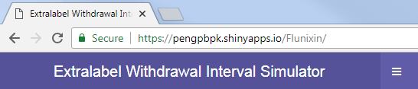

**Second** option is to open the Rshiny app locally. If the app files available on the local computer, the simulator can also be opened by using RStudio. Make sure you have RStudio installed on your local computer, before running the app. Please refer to RStudio Tutorial (http://web.cs.ucla.edu/~gulzar/rstudio/) for details of RStudio installation and some basic information.

Double click the ‘app.R’ in the app file to open the app in RStuido, or by ‘File > Open File … > Flunixin App/app.R’ in RStudio. Once you open the “app.R” file, you can click the “Run App” button to run the app on your local computer. We recommend to run the app on your local computer as Monte Carlo simulation for 1,000 animals is more stable to run on your local computer compared to the server online.

Note: If run the app on the local computer using RStudio, please click the ‘Open in Browser’ button to run the app in the web browser to avoid abnormal issues. If you click “Open in Browser”, it looks like you are on a web page, but still it runs locally.

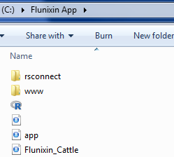

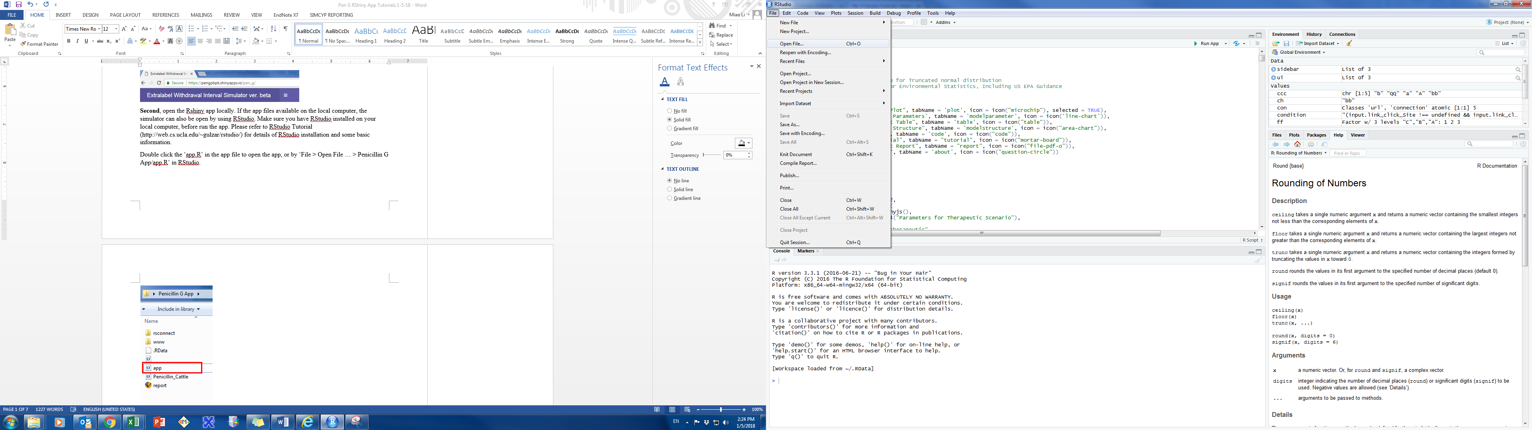

**Double Click to Open**

**Click ‘Run App’ in RStudio**

**Click ‘Open in Browser’ Button**

**Using RStudio to Open**

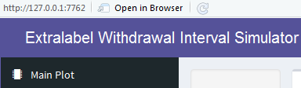

1. Interface Structure

The application interface contains four major parts including ‘Title Panel’, ‘Side Panel’, ‘Parameter Input Panel’, and ‘Output Panel’.

**Side Panel**

**Title Panel**

**Parameter Input Panel**

**Output Panel**

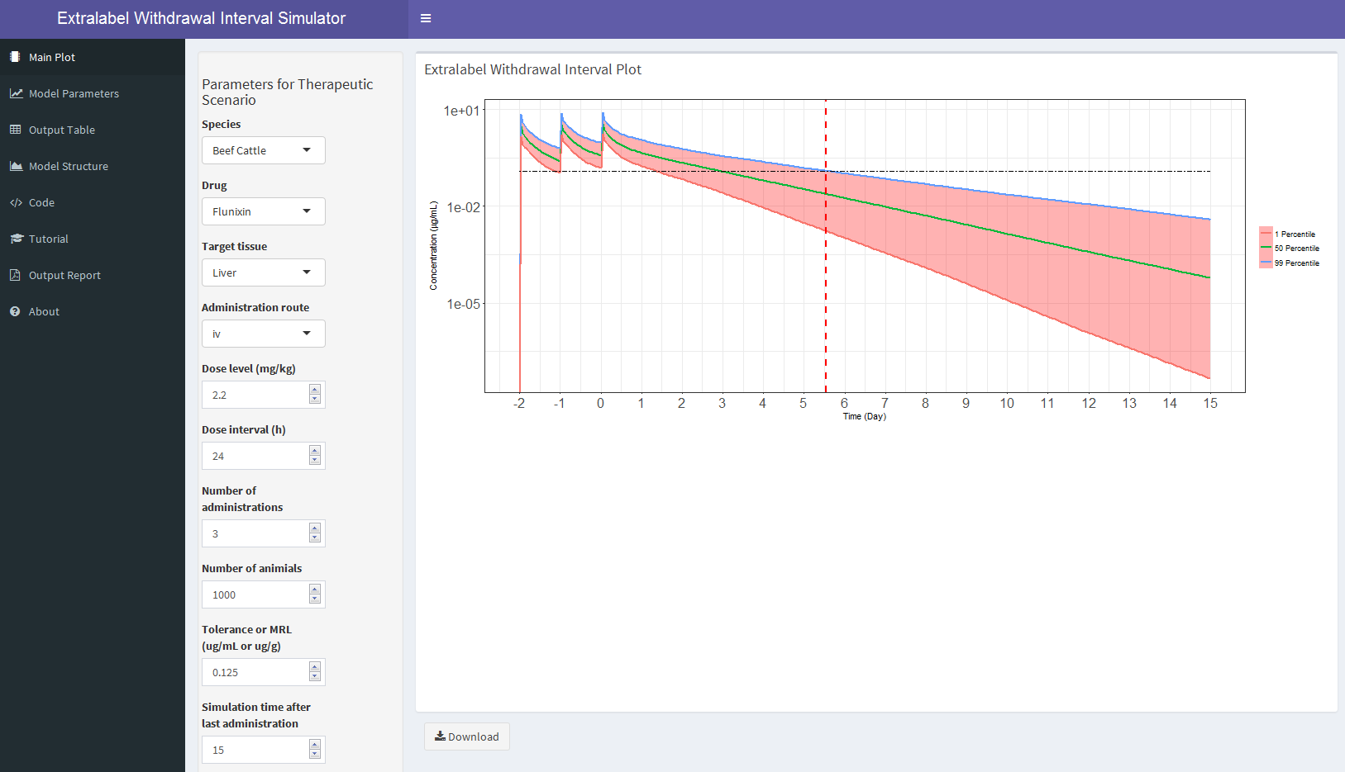

The ‘Title Panel’ includes the title ‘Extralabel Withdrawal Interval Simulator’ and the side panel controller. By clicking the side panel controller, you can choose to show up or hide the side panel.

**Title**

**Side Panel Controller**



The side panel contains ‘Main Plot’, ‘Model Parameters’, ‘Output Table’, ‘Model Structure’, ‘Code’, ‘Tutorial’, “Output Report”, and ‘About’ tabs. By clicking the tab name, you can switch among these tabs.

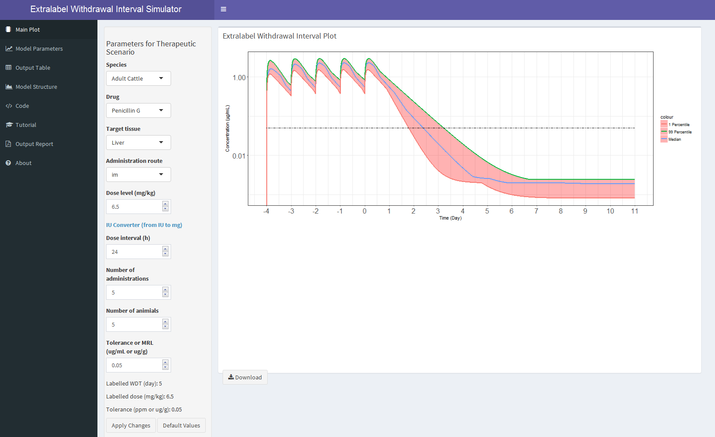

The ‘Main Plot’ and ‘Model Parameter’ tabs have parameter input panel. There are different types of controllers, such as switching buttons, dropdown lists, and input boxes. By clicking the

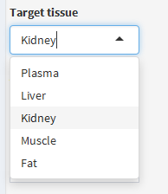

**Dropdown List**

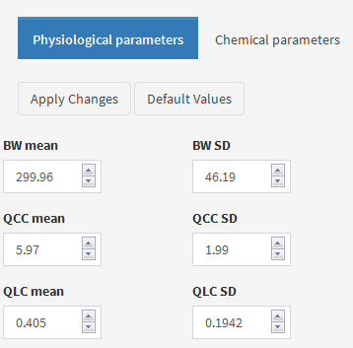

**Switching Button**

**Input Box**

switching buttons, you can choose in-between different conditions. For dropdown lists, you can choose different choices by clicking the downwards arrow. For input boxes, you can directly type in the value, or use the arrow to increase or decrease the default value provided.

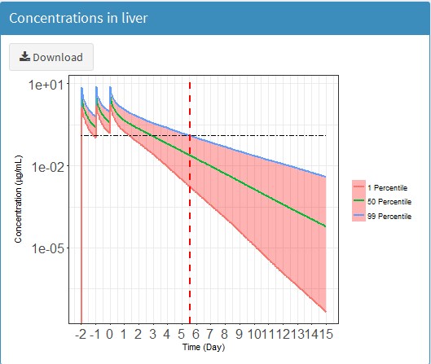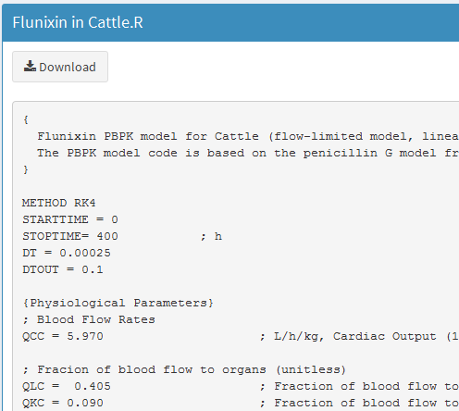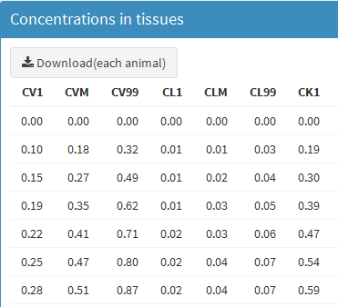All the tabs contain the output panels. For ‘Main Plot’, ‘Model Parameters’, and ‘Output Table’, the output panels show the simulation results using the parameter values you choose. The output panels in ‘Model Structure’, ‘Code’, ‘Tutorial’, and ‘About’ tabs provide information about the simulator, and are independent from model simulation output. You can download figures, tables or related codes by using the ‘Download’ button.

**Download Buttons**

1. “Main Plot” Tab to Predict Extralabel WDIs

You can use the main tab (“Main Plot”) to predict withdrawal intervals following extralabel use of veterinary drugs. By changing values of major parameters for therapeutic scenarios, the simulator will provide “Extralabel Withdrawal Interval Plot” as output.

**Step One**: Choose “Main Plot” tab (this is the default page, when you open the simulator)



**Step Two**: By clicking the ‘Apply Changes’ button, you can run the simulator using the default values for all parameters. The “Apply Changes” button is on the bottom of the Parameter Input Panel. Once you click the “Apply Changes” button, the model will start running and you will see a progress bar “Creating plot Please Wait” on the right bottom corner. The default setting includes 1000 animals in a Monte Carlo simulation, so the simulation will be completed within 1 minute.



**Step Three**: You can also change the parameter values by using dropdown lists or input boxes. For example, if you want to know the WDI for m swine treated with 2.2 mg/kg flunixin for 3 times with 24 hour intervals, and you want the simulator create a population with 1000 animals, you can choose “Market-age Swine” in “Species”, “Liver” in “Target tissue”, “1000” in “Number of animals”, and “0.03” in “FSIS action level” (0.03 ug/g is the tolerance for flunixin in swine liver). All the other values are the same as default. After clicking the ‘Apply Changes’ button, the simulator starts to run simulations with the parameter values you input. When the simulations finish, the simulator will provide the pharmacokinetic profile of flunixin in liver in the output panel.

**Output Panel**

**Parameter Input Panel**

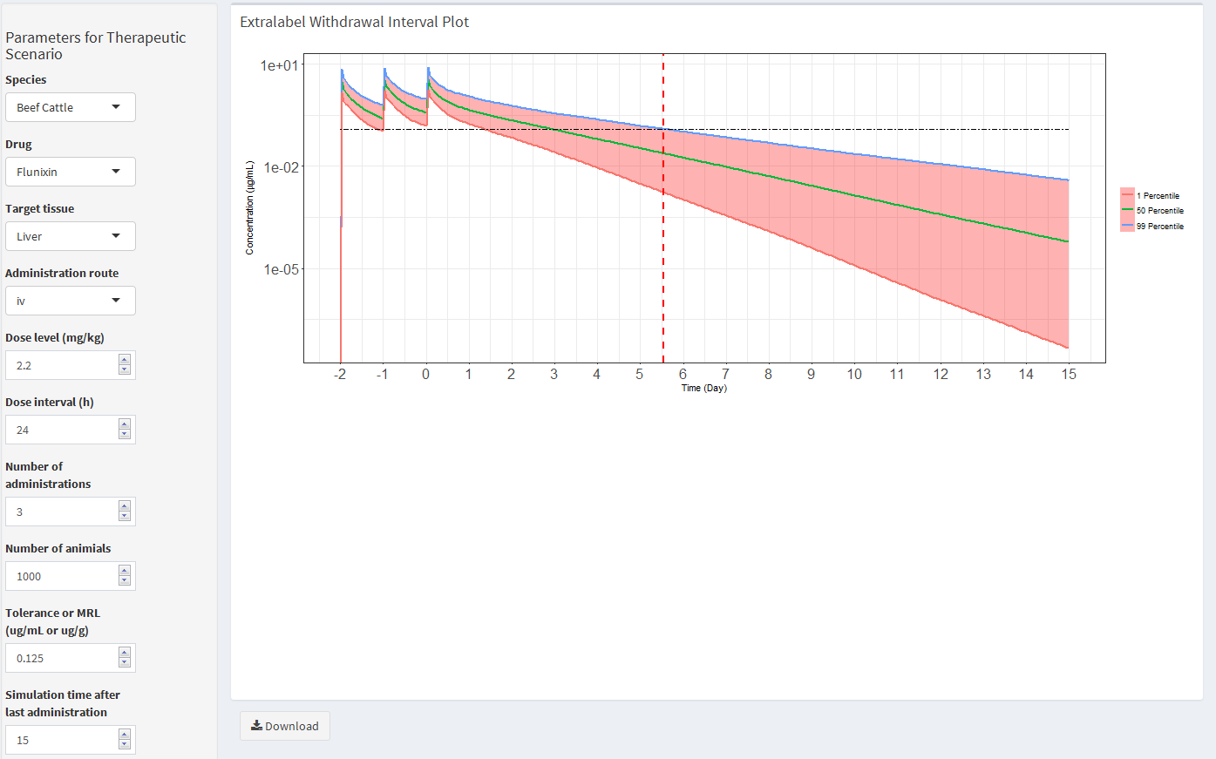

1. “Model Parameters” Tab to Change Values for Physiological or Chemical Parameters

In the PBPK model, there are two types of parameters involved, including physiological parameters and chemical-specific parameters. Generally, the simulation results generated based on the default parameter values are sufficient to answer most of FARAD calls. We recommend you directly use the default physiological/chemical-specific parameters to run the simulations. For advanced users, these values could also be revised to make the simulations more relevant to a particular scenario they want to simulate. If you need to use this function and have any questions, please feel free to contact the interface development team.

**Step One**: Choose “Model Parameters” tab

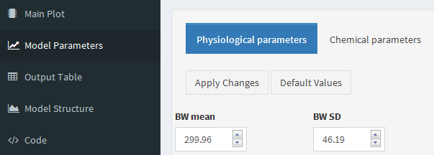

**Switching Button**

**Step Two**: In the parameter input panel, you can choose to use your customized values in ‘Physiological parameters’ or ‘Chemical parameters’ by using the switching buttons.

**Step Three**: By using input boxes, you can put your customized values for the parameters you are interested in. For example, if you want to simulate a group of swine with mean body weight as 50 kg, and standard deviation as 10. On the “Model Parameters” tab, you change the BW mean value from the default value to 50, and change the BW SD value from the default value to 10 (see the figure below). Then you go back to ‘Main Plot’ tab, and click apply changes. The results will be generated after all simulation finishes.

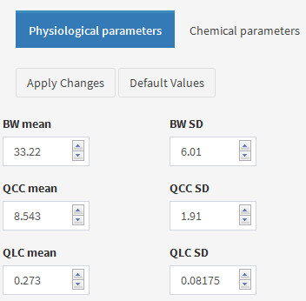 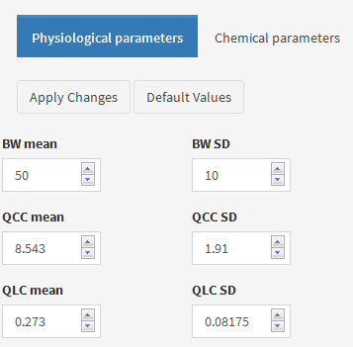

**Input Box**

**Switching Button**

1. Download Figures and Tables from “Model Parameters” and “Output Table” Tabs

After the desired simulations, there are output figures and tables you can save to files in your local computer. In the “Model Parameters” tab, you can download figures of pharmacokinetic profiles in major edible tissues, including liver, kidney, muscle, and fat. You can also download the table of pharmacokinetic data for the drug in different edible tissues. Note that the generated table only contains the 1th, 50th, and 99th percentiles of the simulated concentrations of the drug in different tissues among the simulated population of animals. Due to the large number of animals that are typically included in a population simulation (e.g., 1,000 animals), the individual animal concentration data are not included in the output table. If individual animal concentration data are needed, please contact the interface development team.

The output report can be downloaded from the “Output Report” tab. By choosing the “Output Report” tab in the “Side Panel”, the output report based on your input parameters could be generated from the simulator. Three different output formats, including PDF, HTML and WORD, could be applied to the output report by click the corresponding radio button. You can use the download button to save the report on your local computer.

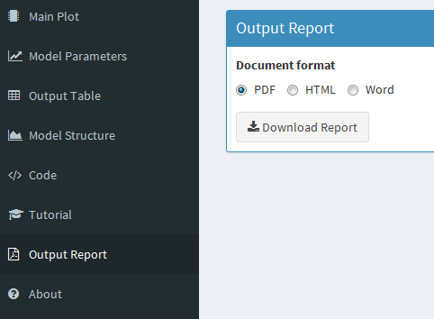

**Download Button**

**Radio Buttons**

1. Common Simulation Results.

All the simulation results reported here are based on the simulations of 1,000 animals with 3 repeated intramuscular (IV) doses for cattle and intravascular (IM) doses for swine. The predicted WDIs for the label use of flunixin are listed below in the table.

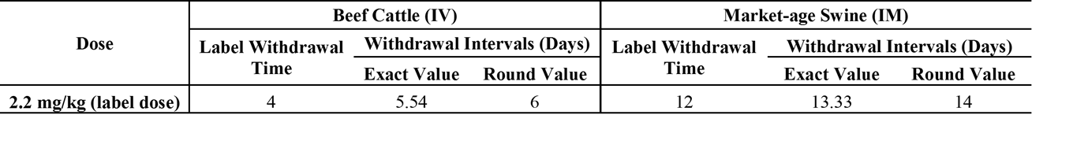

Note: The labeled withdrawal time of flunixin is based on the formulation NADA 101-479. The labeled indications are 2.2 mg/kg daily IV injection for up to 3 days of treatment for cattle and 2.2 mg/kg through single IM injection for swine (all use classes).

Related simulation results are shown blow in figures.

**C:\R\workingfiles\Rshiny\Flunixin\graph2.tif**

# **Acknowledgement**

The project is supported by the United States Department of Agriculture National Institute of Food and Agriculture for the Food Animal Residue Avoidance Databank (FARAD) Program (http://www.farad.org/).